1 – Faith of Abraham
Hebrews 11:8-19

2 - Walking through the OT scriptures
- Lessons in the Garden of Eden. (Genesis 1-3)
- Lessons learned from Cain and Abel. (Genesis 4)
- Lessons learned from Noah and the flood. (Genesis 6-7)
- Lessons learned from the promises to Abraham and his faith in God. (Genesis 12)

3 - 5 Key Old Testament Passages
- Genesis 3:15 - God’s promise of Satan’s defeat.
- Genesis 12:1-3 - God’s promise of blessing to all the nations of the earth through Abraham.

4 - Abraham: the Christian’s model of faith
- We must have the faith that surrenders all to God.
- We must be “those who are of the faith of Abraham”. (Romans 4:16; Gal. 3:7; cf., 2 Peter 1:3)
- Our call to become Abraham’s seed.
(Gal. 3:29; cf., vs. 26-27)
- We must “do the deeds of Abraham” by faith
(John 8:39; cf., Luke 3:8)

5 - Background of Abraham
- About 2,000 years after the creation and about 2,000 years before Christ and 400 years after the flood.
- God used Abraham to preserve righteousness as Noah did.

6 - Background of Abraham
- From Ur of Chaldea where he lived until about age 70 in a very idolatrous, yet cultured and abundant environment.
- Abraham had two brothers; Nahor and Haran. Haran died in Ur before God called him. (Genesis 11:27-32)
  - Lot was the son of Haran.
  - Abraham’s father was named Terah.

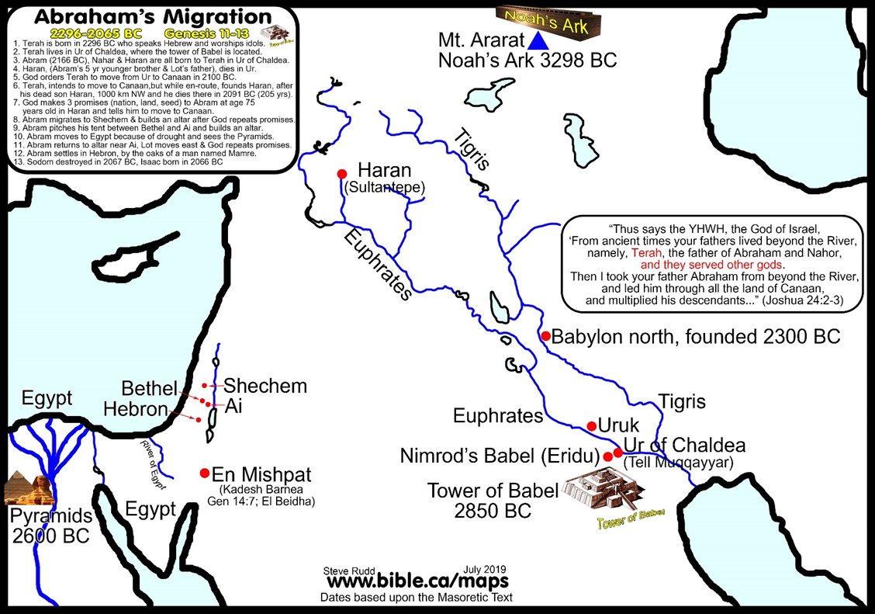
7 - Background of Abraham

8 - Background of Abraham
- We might ask, how did Abraham come to believe in God in such an idolatrous environment?
- Remember Romans 10:17!

9 - Background of Abraham
- While in such a wicked environment, God called to Abraham to “leave your country and your relatives, and come into the land that I will show you.” (Acts 7:3-4)
- Abraham’s father, brother and nephew all came with him as far as Haran (Genesis 11:31) where they spent about 5 years and where his father Terah died.

