1 – The Kingdom Divided
1 Kings 12 & 13

2 - How We Got Here…
- “Solomon loved the Lord… except…” (1 Kings 3:3)
- Given discernment by God. (1 Kings 3:6-14)
- Solomon builds and dedicates the temple. (1 Kings 7:51; 8:22ff)
- Note Solomon’s prayer in 1 Kings 8:56-61; “Let your heart therefore be wholly devoted to the Lord our God…”
- Solomon blessed by God and became “greater than all the kings of the earth”. (1 Kings 10:23)
- “Solomon loved many foreign women” who “turned his heart away” and he “did what was evil in the sight of the Lord and did not follow the Lord fully…” (1 Kings 11:1-6)

3 - How We Got Here…
- “The Lord was angry” and promised to “tear the kingdom from you” and “give it to your servant.” (1 Kings 11:9-11)
- Yet not… (1 Kings 11:12-13)
  - “In your days”
  - “All the kingdom” - 2 tribes would remain. (2 Samuel 7:12-16)
    - Ahijah the prophet tells Jeroboam he will be given the kingship in the northern 10 tribes. (1 Kings 11:29-38)
- Solomon’s death… (“Good king?” How will our life end?)

4 - King Rehoboam
- “All the assembly of Israel came and spoke to Rehoboam…” saying “lighten the hard service of your father… and we will serve you.” (1 Kings 12:3-4; cf., 1 Samuel 8:10-20)
- The counsel of the elders…
  - “Be a servant to this people…” (vs. 7; cf., Luke 22:26)
(it’s about them!)
- The counsel of his peers…
  - Show ‘em who’s boss! (vs. 10-11) (it’s about you!)
- Jeroboam did not listen… Who are we listening to? (Psalms 1:1-2; 73:24; Proverbs 1:5, 25)

5 –
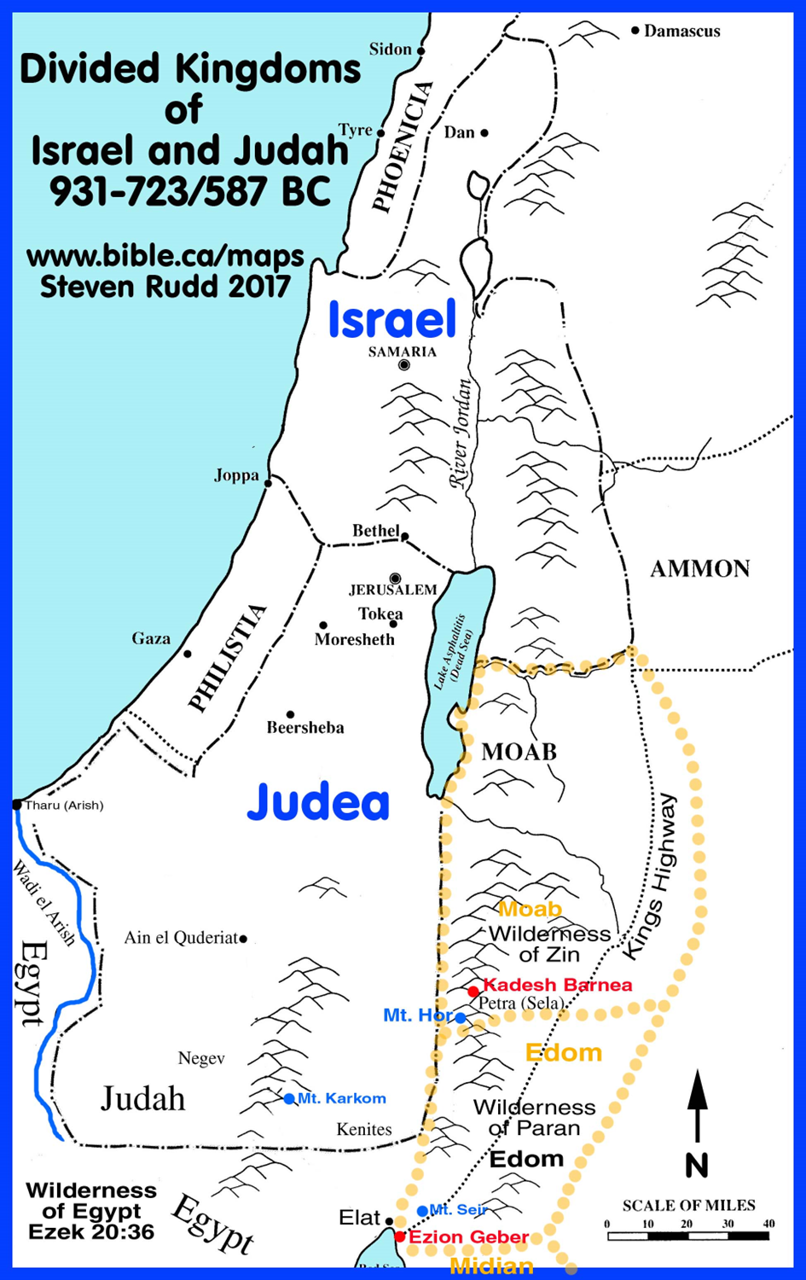

6 - King Jeroboam
- Who was he? (1 Kings 11:11, 28)
- He was told why the 10 tribes were being taken from Solomon. (1 Kings 11:33)
- He would be given a chance to establish his kingdom. (1 Kings 11:38)
- Solomon sought to kill him (1 Kings 11:40), so he fled to Egypt until Solomon’s death.

7 - King Jeroboam
- His reign…
- He was shrewd… (1 King 12:25-27)
- “It is too much for you to go up to Jerusalem…”
(1 Kings 12:28)
  - One of Satan’s schemes and deceptions… what God asks of us is “too much”. (Matthew 19:23ff; 2 Cor. 8:5;
2 Sam. 24:24; Heb. 10:23-25; Acts 17:11; 2 Tim. 3:16-17; 1 Cor. 1:10; Phil. 2:3-4)

8 - King Jeroboam
Revised worship
- Changed the object. (1 Kings 12:28)
- Changed the place. (1 Kings 12:29)
- Changed the priesthood. (1 Kings 12:31; cf., Num. 3:10)
- Changes the feasts. (1 Kings 12:32; Lev. 23:34)
- Changed the authority to that “which he devised in his own heart”. (1 Kings 12:33)

9 - Judgement Upon King Jeroboam
“A man of God” came by “the word of the Lord” to Jeroboam while standing at the altar he made at Bethel and “cried against” Jeroboam and his wickedness. (13:1)
The man of God identifies by name (Josiah) who would bring judgment upon his house approx. 300 years in the future. (13:2)

10 - The man of God’s lack of faith
The man of God understood his instructions. (1 Kings 13:9)
The man of God also lacked faith in what he was told.
(1 Kings 13:18-19)
The man of God lost his life for his lack of faith and obedience. (1 Kings 13:24-26)
Jeroboam failed to learn any lessons from God. (1 Kings 13:33)
God has spoken, do you know what He said?
Are you faithful to it?

11 - Why the kingdom was divided?
- Not being wholly devoted to the Lord.
- More focused on temporal pleasures.
- Solomons heart was turned away from God.
- Focus on convenience rather than pleasing God.
- Lack of faith in God’s promises.
- Lack of divine authority.
- Failure to love the truth.

