1 – Reasons For Serving God
Genesis Chapters 27 & 28
2 - God is concerned with the “Why” in our service unto Him
Are there wrong reasons to serve the Lord?
- More than just how, where, when and what, our “why” is critically important to God and our ability to endure and overcome.
- Our reasons will become manifest. (1 Corinthians 4:5)
- It is only through true “purpose of heart” (NKJV) that we will “remain faithful to the Lord” (ESV). (Acts 11:23)
- Understanding “service”… (Ephesians 4:12; 1 Timothy 1:12; 2 Timothy 2:4; “attendance (as a servant)” (Strong) Luke 1:38)
- A reminder of what the faithful will do in heaven. (Revelation 22:3-5; 7:15)
3 - Our reasons for Serving God
Who is at the center of our lives?
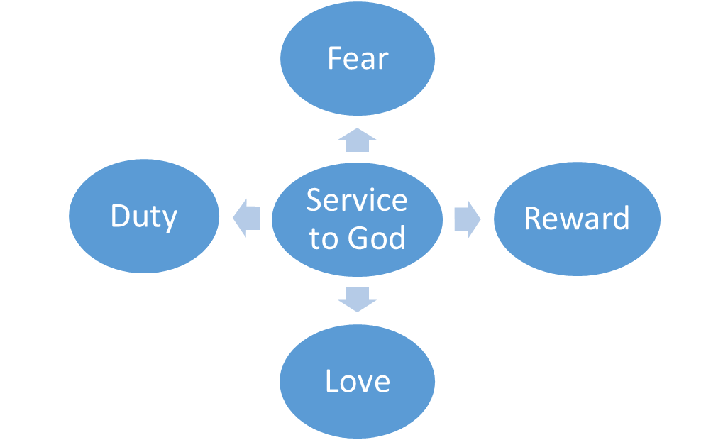
4 - Godly Fear
Defined as “to reverence, venerate, to treat with… reverential obedience” (Thayer)
- Our service to God must begin by recognizing who He is… that is, the Creator of all things and the giver and sustainer of life. (Psalms 100:1-3; 95:1-8; 119:73; Exodus 20:20; Hebrews 12:28-29)
- An inseparable link between godly fear and obedience. (Ecclesiastes 12:13-14)
- Includes reverence for His will. (Psalms 4:4; Malachi 2:5)
- Shown by putting Him first & abounding in his work.
(Haggai 1:12; 1 Corinthians 15:58)
- Key to our “persuasion” (2 Corinthians 5:11) as well as our continued pursuit of holiness. (2 Corinthians 7:1)
5 – Love
Agape love is an act of the will and not of the heart that seeks the best interest.
- Defined by God toward us and to reciprocated to Him in like kind.(1 John 4:7-21)
- To be extended to all others including brethren (John 13:34; John 15:12; 1 Thessalonians 4:9-10); the lost (John 3:16) and even our enemies (Matthew 5:44)
- Without it, my service will “profit me nothing”. (1 Corinthians 13:1-3)
- “Perfect love casts out fear” as the primary driver of our service to God. (1 John 4:18)
6 – Duty
Defined as “to owe… (be) under obligation” (Strong)
- Based on our fear, it’s our duty to serve God. (Luke 17:10)
- It’s our reasonable or rational service! (Romans 12:1-2)
- Often translated “ought”… (Hebrews 5:12; 1 John 4:11; John 13:14) because of what He has done for us.
- Not “I have to…” but eager and unashamed. (Romans 1:14-16)
- “Make Me A Servant” - (Luke 15:19; 2 Timothy 2:21)
- What we are to “render to God”. (Matthew 22:21)
- When and with what? (Matthew 6:33; Haggai 1:4-7; Malachi 1:8; 3:10; 2 Corinthians 8:5)
7 – Reward
When are we seeking our reward? (Matthew 6:1; Hebrews 11:13-16, 26)
- “What then will there by for us?” (Matthew 19:27; Psalms 19:11; Psalms 58:11
- “Looked to” by those who walk by faith. (Hebrews 11:10, 13-16)
- With the “eyes of your heart” (Ephesians 1:18-20) looking not at the seen but the unseen. (2 Corinthians 4:16-18)
- Looking forward with anticipation and longing - not fear and trepidation. (1 John 2:28; 2 Peter 3:10-15)
- Preparations to be made (Matthew 25:1-13)… Endurance to be exercised. (Hebrews 10:32-39; Luke 21:19)
8 - Will You Choose to Serve The Lord Today?
- Out of reverence and respect for who He is (our Creator and Redeemer) and understanding of who we are (sinners who wish to be reconciled)?
- Out of love for what He has done for us?
- Out of duty because He deserves our faithful obedience?
- Because you believe in His promises and you earnestly seek the eternal reward?

