1 - The Weight Of The World On His Shoulders” - Jesus In The Garden of Gethsemane
Mark 14:32-42
2 - Before Gethsemane
Jesus predicted His suffering and death. (Matthew 16:21; 17:12, 22-23; 20:17-19)
Jesus already praying about it (Luke 9:28-32) and preparing for it. (Luke 9:51; (cf., Isaiah 50:7) John 12:27)
Ready to lay down His life. (John 10:17-18; cf., 18:1-8)
3 - Before Gethsemane
The day before…
- Observance of the last Passover & washing of the apostles feet. (Mark 14:12-17; John 13:1-20)
- Answered who’s greatest. (Luke 22:24-30)
- Identification of His betrayer (Mark 14:18-21) & prediction of Peter’s betrayal. (Mark 14:26-31)
- Jesus’ prayer for Himself (John 17:1-6), His apostles (John 17:7-19) & for us! (John 17:20-21)
4 - Leaving Jerusalem…
“As was His custom”, (Luke 22:39), they go to the Mount of Olives (Matthew 26:30) where Jesus says that “you all will fall away”. (Matthew 26:31)
After Peter avows he will “never fall away”, Jesus reminds Peter (Matthew 26:33-34; Luke 22:34) that he will deny Him 3 times.
Jesus takes Peter, James and John with Him as He goes to pray. (Mark 14:32-33)
5 - The Garden Of Gethsemane…
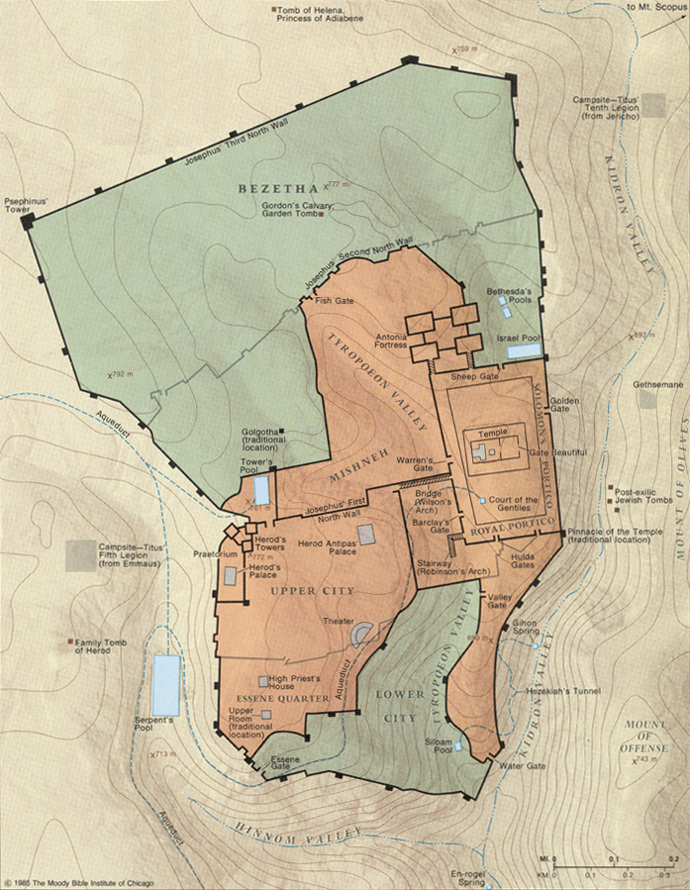
6 - Jesus Alone In The Garden…
Jesus “fell on His face” (Matthew 26:39) & was “very distressed and troubled” and said, “My soul is deeply grieved to the point of death; remain here and keep watch.” (Mark 14:33-34)
- “Troubled” - uncomfortable, as not at home, to be troubled, distressed: (Thayer’s Lexicon),
- “Deeply grieved” - “grieved all around, intensely sad…” (Strong) (Psalms 42:11; Luke 18:23)
7 - Jesus Alone In The Garden…
Jesus was “very distressed and troubled” and “fell on His face” (Matthew 26:39)
Why? (Isaiah 53:7) Jesus truly had the “weight of the world” on His shoulders.
- Note what “Gethsemane” means!
- What is being asked of Him? (Hebrews 5:8)
8 - Jesus’ Request Of His Disciples…
“Remain here and keep watch with Me” (Mark 14:34)
  - Why? (1 Peter 2:21-25; Mark 14:38)
  - Are we? (1 Thessalonians 5:1-11; Colossians 4:2)
  - A call for sober mindedness! (1 Peter 5:8-10)
“Pray that you may not enter into temptation”
(Luke 22:40; cf., Matthew 6:13)
9 - What Jesus Found In His Disciples…
“He came and found them sleeping…” (Mark 14:37)
  - “Could you not keep watch for one hour? Keep watching and praying that you may not come into temptation; the spirit is willing, but the flesh is weak.” (Mark 14:38)
  - A 2nd time, “they did not know what to answer Him.”
  - A 3rd time “the hour has come…” (Mark 14:41-42)
10 - Jesus’ Request Of His Father…
Jesus again prayed to His Father.
A life of prayer to His Father. (Mark 1:35; Matthew 14:23; Luke 6:12; 9:18, 28-31)
When we turn to God in prayer in a time of crisis or peril, will we be addressing a stranger or a friend? (2 Kings 20:1-6)
The need for persistence & faith. (Luke 11:8; 18:6-8)
11 - Jesus’ Request Of His Father…
“That if it were possible, the hour might pass Him by.” (Mark 14:35; remember John 12:27-28. Also note John 2:4; 8:20)
“Abba! Father! All things are possible for you; remove this cup from Me; yet not what I will, but what you will.” (Mark 14:36)
Sometimes the answer is no. (2 Corinthians 12:7-10)
12 - Jesus’ Submission To His Father…
- Note John 12:27-33 - suffering before glory. (Luke 24:26; 1 Peter 5:10; 1:6-7)
- Jesus always sought the will of His Father
(John 8:29; (cf., John 4:34)
- Jesus had a choice to make. (Matthew 26:53)
- He chose to drink “the cup”. (John18:11)
13 - Lessons Learned In The Garden…
- The power of prayer and the need for watchfulness & sober mindedness. (1 Peter 5:6-7; Hebrews 4:14-16)
- Willing to suffer for the cause of Christ for the glory yet to come. (Lk. 24:26; Heb. 2:10; 1 Peter 1:11)
14 - Lessons Learned In The Garden…
- Submission to the will of God. (Matthew 6:10; Hebrews 5:8-9) The need to finish our race.
(2 Timothy 4:7-8; John 20:30; Hebrews 4:1)
- The need to take advantage of the blood He shed.
- The need to live for Him who died for us. (Galatians 2:20; Romans 12:1-2)

