1 - Now that I’m a Christian, Then What?
Acts 2:38-42

2 - What did they do in Acts chapter 2?
Note Acts 2:42,
“They were continually devoting themselves to the apostles' teaching and to fellowship, to the breaking of bread and to prayer. “
Who are the “they”?

3 - “Continually devoted…”
Defined: “to be earnest towards…to persevere, be constantly diligent… to attend assiduously all the exercises… adhere closely to (as a servitor): attend (give self) continually”. (Strong)
“To tarry, remain somewhere… continue steadfastly with someone…” (Zodhiates)

4 - Continual Devotion
We need to choose our devotion!
Matthew 6:24, “No one can serve two masters; for either he will hate the one and love the other, or he will be devoted to one and despise the other. You cannot serve God and wealth.”
(1 Kings 8:61; 11:4; 2 Corinthians 11:3; Romans 12:10)
Devotion to Christ and not to any person.
(1 Corinthians 1:10-17; 3:21-23; Ephesians 4:11-16; Galatians 3:27-29)

5 - “Continually devoted to the Apostles doctrine…”
Then what? New Christians need a lot of teaching! (Matthew 28:18-20)
- As babes in Christ, they need to seek to consume it and we need to seek to provide it! (1 Peter 2:1-2; Matthew 5:6; Hebrews 5:12-14)
- Need for continual growth. (2 Peter 3:17-18; Heb. 6:1)
- It’s what builds us up and nourishes us. (Acts 20:32;
1 Timothy 4:6, 16; cf., Acts 17:11)

6 - “Continually devoted to… Fellowship”
“Fellowship” defined -
- W. E. Vine: fellowship is from the Greek word ‘koinonia’ and means; “communion, fellowship, sharing in common…”
- Marvin Vincent: defines ‘koinonia’ as; “a relation between individuals which involves a common interest and a mutual, active participation in that interest and in each other… a co-operation…”
“Participation” (Zodhiates)

7 - “Continually devoted to… Fellowship”
What is it that these 3000 people just shared or participated in?
Their faith in, and obedience to the gospel!
They were “continually devoted” in their continued sharing and participation in the gospel.
Being part of the Lord’s church is something that we participate and share in rather than be a spectator of.

8 - “Continually devoted to… Fellowship”
“Fellowship” (koinonia/koinoneo) used in scripture -
- Philippians 1:5, “In view of your participation in the gospel…”
- Philippians 4:15, “…no church shared with me in the matter of giving and receiving but you alone.”
- Romans 15:26-27, “… a contribution for the poor… Gentiles…shared in their spiritual things…”
- 2 John 11, “… gives him a greeting participates in his evil...”

9 - “Continually devoted to… Fellowship”

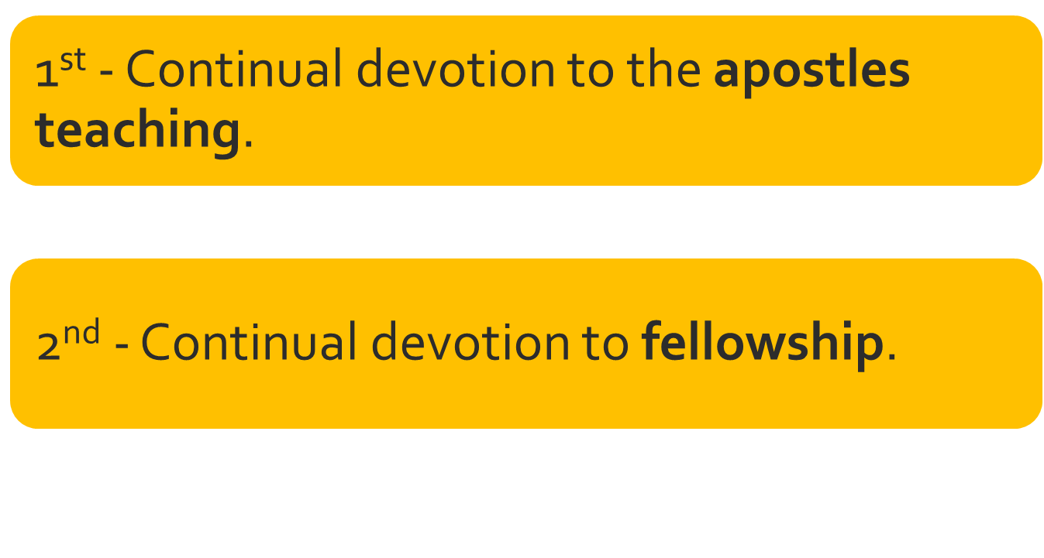
- A commitment to continually grow and learn.
- A joint participation in the gospel of Jesus Christ and the apostle’s doctrine.
10 - Now that I’m a Christian, Then What?
Devoted to fellowship… What fellowship requires of me?

11 - “Continually devoted to… Fellowship”
- From the Greek word ‘koinonia’ meaning; “communion, fellowship, sharing in common…”
- “A relation between individuals which involves a common interest and a mutual, active participation in that interest and in each other… a co-operation…” (Vincent’s Word Studies)

12 - “Continually devoted to… Fellowship”
- What is our “common interest” and what do we “share in common”?
- “…Our common salvation…” that we are to “contend earnestly for…” (Jude 3)
- Having a “common faith”. (Titus 1:4)
- “A faith of the same kind as ours…”; “like precious faith…” (NKJV; ASV)

13 - “Continually devoted to… Fellowship”
Fellowship with who or what?
- First with God then with all others in fellowship with God.
(1 John 1:3-7)
How do we come into this fellowship -
- Through the gospel. (1 Corinthians 1:9; 2 Thessalonians 2:13-14)
Thus, above all else, fellowship is a sharing & participation in the gospel - something spiritual & not physical. (Philippians 1:3-5 )
Those taught the apostles doctrine are to share with those who taught them. (Galatians 6:6-10)

14 - 1 John 1:1-3
Keeping His Commandments - 1 John 2:3; 3:24; 2 John 6
Practicing "the truth“/”righteousness” - 1 John 1:6; 3:7-9

15 - “Continually devoted to… Fellowship”
What establishes fellowship with God establishes fellowship with others who have also done - and are doing - the same.
What breaks ones fellowship with God also breaks our fellowship with one another.
We cannot extend our fellowship to anyone who is no longer in fellowship with God. (2 John 9-11)
“Let us build with you…” (Ezra 4:2) Spoken by Samaritans

16 - “Continually devoted to… Fellowship”
How do we share or jointly participate in the gospel?
- We do whatever we can to contribute as a functioning member of the body! (Ephesians 4:16; Romans 12:4-8; 1 Peter 4:11; Matthew 25:14ff)
- How a new Christian “jointly participates” and “shares” in the will change as they experience spiritual growth.
- Am I doing what I can? (Mark 14:8)
- Ask, “what can I do?”

17 - “Continually devoted to… Fellowship”
Have I done what I ought?
Sharing in the work God has authorized…
- Some would argue, “at least I’m doing something!” (Matthew 7:21-23; 2 John 9)

18 - “Continually devoted to… Fellowship”
The proper attitudes to be in fellowship with God -
- Humility (James 1:21; Isaiah 55:8-9)
- Faith (Acts 27:25)
- Reverence (Hebrews 12:28)
- Love (John 14:15)
- Joy (1 Peter 1:8)
Demonstrated by our: Worship, work, time and our being.

19 - “Continually devoted to… Fellowship”
The proper attitudes to be in fellowship with our brethren -
- Humility (Philippians 2:3-5; 1 Corinthians 10:23-24)
- Love (1 Corinthians 13; 16:14)
- Joy (1 Thess. 2:19; 3:9; 2 Timothy 1:3-4; 2 John 12; 3 John 4)
Demonstrated by our:
- Sacrifice, Labor and Time.

20 – “Continually devoted to… Fellowship”
Are you in fellowship with God?
Is your fellowship with God directing your fellowship with your fellow brethren?
Are you yet walking in the light? (1 John 1:3-10)
Do you need the cleansing power of the blood of Jesus Christ?

