1 – Lessons From Uzza (And David) –
1 Chronicles 13

2 –
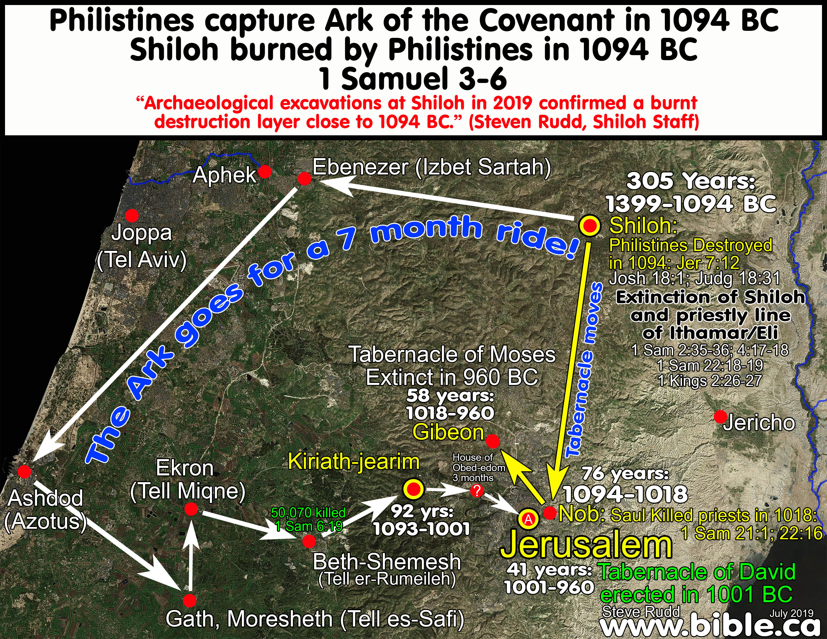

3 - Brief History Of The Ark Of The Covenant
- Exodus 25:10-14, Moses commanded to build the ark of Acacia wood and designated how it was to be carried… only by the sons of Kohath of the tribe of Levi (Numbers 4:4, 15; Numbers 7:9).
- The Israelites lose the ark in a battle against the Philistines, and then God smites the Philistines who send the ark back to the Israelites at Beth-Shemesh where 50k die because they look in the ark. (1 Samuel 4-6)
- The ark is sent to Kiriath-jearim to the house of Abinadab where 20 years goes by before they seek God and deliverance from the Philistines. (1 Samuel 7)

4 - Brief History Of The Ark Of The Covenant
- Israel then demands a king “when Samuel was old”
(1 Samuel 8) approximately 20 years later - King Saul who reigns for 40 years. The ark continues to remain in Kiriath-jearim.
- David becomes king of Israel and after 7 years of his reign, he moves the kingdom from Hebron to Jerusalem and decides to bring the ark to Jerusalem after approximately 92 years. (2 Samuel 6 & 1 Chronicles 13; note vs. 1-3)
- Without referring to God’s command, and perhaps by referencing how the Philistines sent the ark back to them, David brings the ark back on a cart. (1 Chronicles 13:7)
- While celebrating it’s return, the cart is upset and Uzza (Uzzah) reaches out to steady the ark and he died. (1 Chron. 13:9-10)

5 – Brief History Of The Ark Of The Covenant
- “Then David became angry because of the Lord’s outburst against Uzza… David was afraid of God that day saying, ‘How can I bring the ark of God home to me?’”
- So he sent it to the house of Obed-edom, whose family God blessed during the 3 months it was there. (1 Chronicles 13:12-14)
- David then builds a place for the ark in the City of David and prepares to bring the ark according to the ordinance of God.

6 - Why Did Uzza Perish?
“God struck him down there for his irreverence (error; NJKV, ESV)…” (2 Samuel 6:7)
Later, David realized, “we did not seek Him according to the ordinance.” (1 Chron. 15:13, note vs. 2; remember 13:2; note 1 Chron. 14 and David seeking God’s will)

7 - Lessons Learned From Uzza & David
- The need to make fellowship with God unconditional. (1 Samuel 6:20; 1 Chron. 13:12; Job?)
- Whom do we seek and consult with?
(1 Chronicles 13:1-3; 15:13)
- Do not learn the way of the nations.
(Jeremiah 10:12; Deuteronomy 12:30)
- Disobedience to God’s revealed cost lives. (Ezekiel 18:20; Joshua 7:1-13)

8 - Lessons Learned Uzza and David
- Intentions do not excuse disobedience.
(Matthew 7:21-23; Acts 18:24-26)
- Our ways are not God’s ways
(Isaiah 55:8-9; )
- God expects and deserves to have His will respected. (Jeremiah 10:12; Deuteronomy 12:30)

