1 - We who have fled for Refuge
Hebrews 6:9-20
2 - David’s Flight From Saul
- Saul turns against David and seeks to kill him. (1 Samuel 18:5-16; 19:1, 11) and David flees from him.
- While on the run from King Saul, David declines two opportunities to kill King Saul. (1 Samuel 24 & 26)
- Persecuted though he had done no wrong. (1 Samuel 26:17-18)
- Saul, his enemy is defeated (1 Samuel 31) and David is delivered.
3 - David sought Refuge in God
- 2 Samuel 22:1-4, “And David spoke the words of this song to the Lord in the day that the Lord delivered him from the hand of all his enemies and from the hand of Saul. 2 He said, ‘The Lord is my rock and my fortress and my deliverer; 3 My God, my rock, in whom I take refuge, my shield and the horn of my salvation, my stronghold and my refuge; my savior, You save me from violence. I call upon the Lord, who is worthy to be praised, and I am saved from
my enemies.” (cf., Psalms 34:8, 22; 52:7; 59:16)
4 - God Provides for Refuge Seekers
- Not all crime/sin intentional. (Deuteronomy 19:4-5 vs. 19:11-13)
- Cities of refuge established to flee to. (Numbers 35:6, 11-12; Deuteronomy 19:1-13; Joshua 20:1-9
- Refuge = Asylum; place of escape
5 –
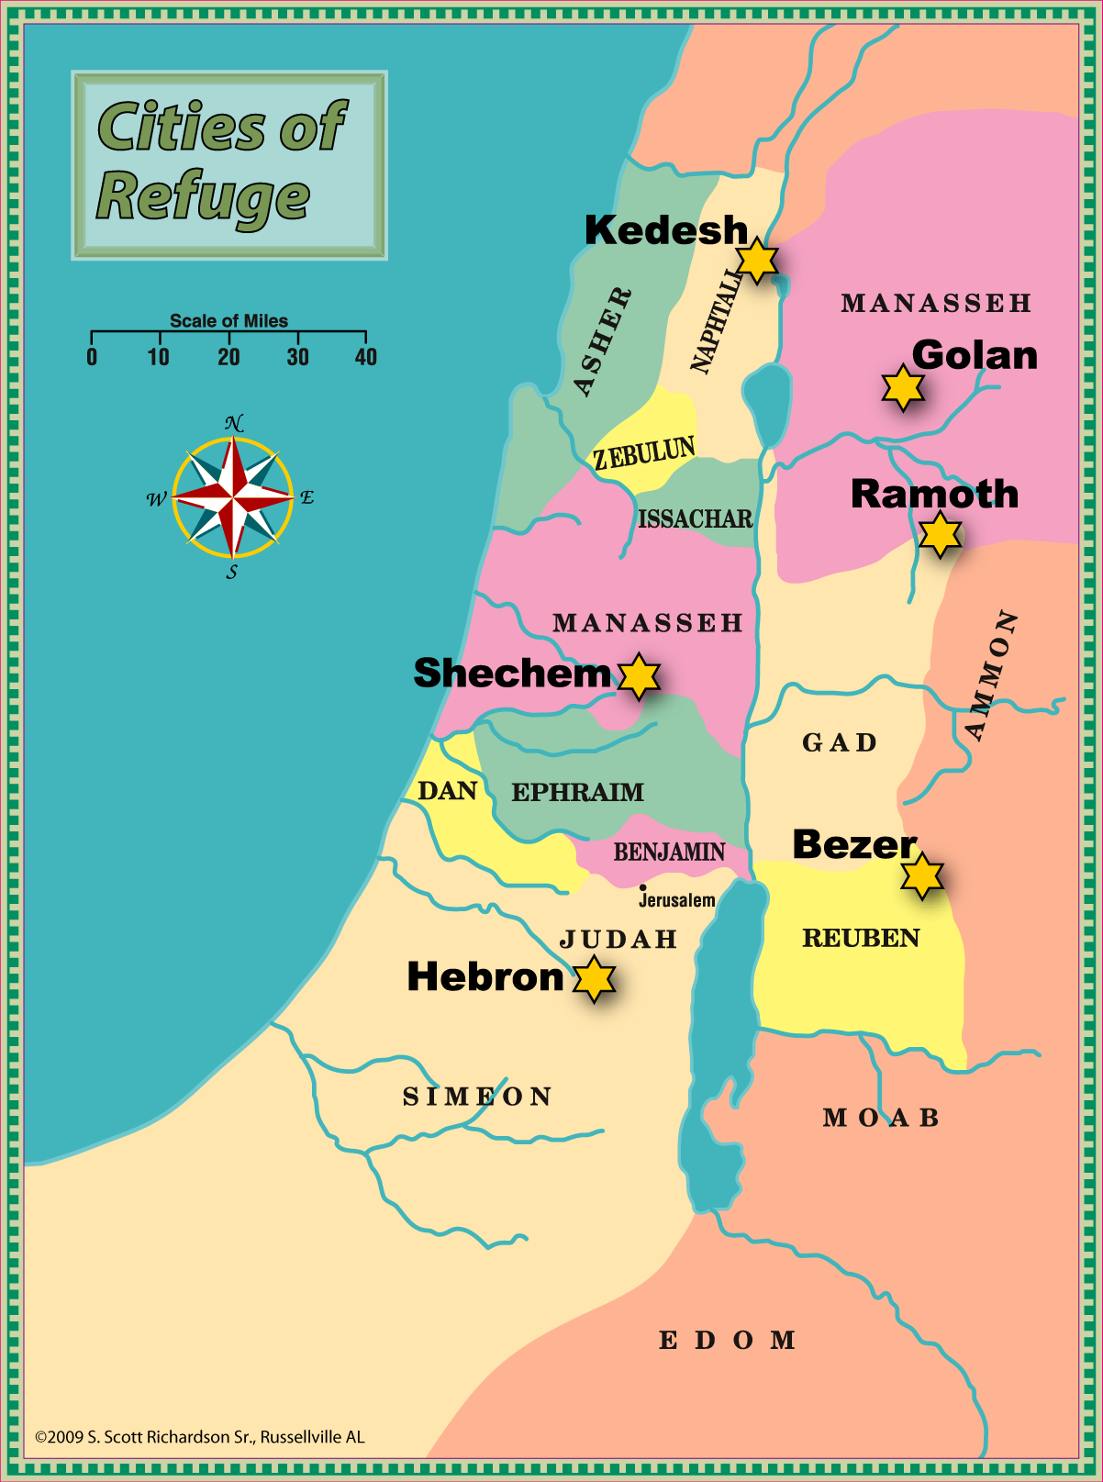

6 - Condemnation brings the need for refuge
- God wants us to seek refuge in Him and His Son – Nahum 1:6-7; Joel 3:16; Isaiah 30:2
- Do we see any need to take refuge? Hebrews 6:17-19
- What can we learn about the cities of refuge that will help us today?
7 - They were to be easily accessible and available to all
- “For all the sons of Israel” (Joshua 20:9; Numbers 35:14) “in the midst of their land” (Deuteronomy 19:3, 6)
- The gospel is for all! (Romans 10:8-13; Titus 2:11-12; Matthew 28:18-20)
- Without partiality – (Acts 10:34-35)
8 - They were to be easily accessible and available to all
- A sense of urgency (Acts 22:16; Hebrews 3:12-15; Matthew 25:1-10)
- Do we realize our guilt and the condemnation of our sins?
- If we see the need to seek refuge, when do we plan on seeking it?
9 - The way was to be made readily known
- “Prepared roads” (Deuteronomy 19:3)
- God has a prepared road and way for us to follow to seek refuge. (Ps. 119:105; John 14:6; Isaiah 55:8-9)
- The road didn’t change! (Jeremiah 6:16; 31:21)
- “We need to spread the good news about the refuge offered by the Lord. (Matthew 28:18-20; 2 Timothy 2:2; Acts 8:4; 2 Kings 7:9)
10 - They were to be well supplied with provisions for survival
- “He shall dwell in that city” (Joshua 20:4; Numbers 35:26 – all that they needed.)
- All spiritual blessings in Christ. (Ephesians 1:3)
- “My God shall supply all your needs”, so don’t worry! (Philippians 4:19; Matthew 6:25-33; 2 Corinthians 9:8-11)
11 - The Gates were to always be open
- The door is always open – for now. (Joshua 20:4; No instructions to come back later.
- Whenever the need to flee – whenever the need for forgiveness. The invitation is always extended. (Matthew 11:28-30; Acts 2:37-38)
- There is such a thing as “too late”. (Matthew 25:10; Luke 13:24ff)
12 - The boundaries of the city were to be respected
- Don’t go beyond… (Numbers 35:26-28; 2 John 9-11)
- Must stay “in Christ”; don’t leave & don’t turn back. (Ephesians 1:3; Galatians 4:9; 2 Peter 2:20)
- God has always defined where safety and salvation would be found. (Exodus 12:22; Joshua 2:17-19)
- John 6:37-38, “All that the Father gives Me shall come to Me, and the one who comes to Me I will certainly not cast out.”
13 - The death of the high priest brought freedom
- Apart from such, remained in bondage. (Numbers 35:28; Acts 13:38-39)
- Our High Priest laid down His life that we might be released from bondage. (Hebrews 9:11-15, 23-28)
- The condemned allowed to live. (Deuteronomy 4:42)
- No longer for the lusts of men but for the will of God. (1 Peter 4:1-3)

